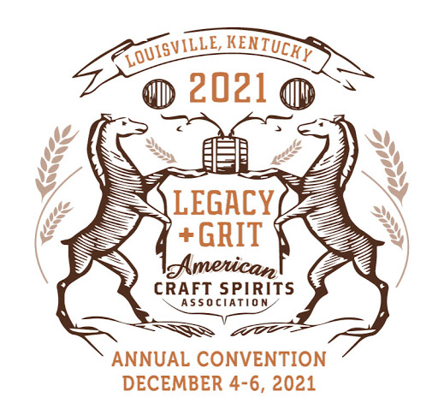
Getting Started in Craft Distilling Pre-convention Course

Join seasoned members of the craft spirits community as they highlight technical/distilling, business/finance, and sales/marketing content geared toward those just starting out. This one-and-a-half-day class will address topics including:
- basic distillery safety
- equipment selection
- oak extraction and aging
- material selection
- flavor chemistry and biochemistry
- TTB compliance
- pros and cons of tasting rooms
- working with distributors
- building a sales team
- General business management
And much more! Course attendees will also receive a binder of relevant content and suggestions for further reading, as this fast-pace course will cover a lot of ground quickly.

