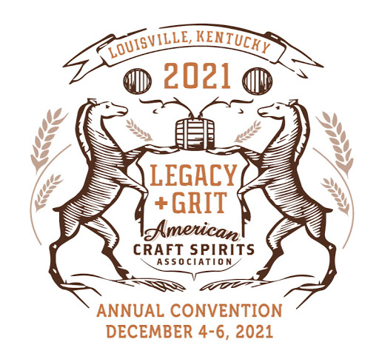
Sensory Pre-Convention Course
Description
Friday, December 3, 2021

8:00-10:30 AM

Gary Spedding (BDAS LLC), Sensory Evaluation and Distilled Spirits Tasting: Sorting out
a few of the Biases that Affect Our Performance and Judgements!

Brewers and winemakers have done a remarkably good job in setting up coherent sensory
programs. Such programs allow careful quality control testing of their beverages, and for
competitive analysis of their beers and wine. By comparison, distillers have a long way to go to
be sure they have a reliable sensory program for analyzing their higher alcoholic strength
beverages. And much of the problem is associated with the pitfalls of bias - an inclination of
temperament or outlook and our personal and sometimes unreasoned judgment! Some of which
is beyond our immediate cognitive coherence.

From a sensory perspective we can be deceived in all the senses – sight, touch, smell and
taste, and even hearing, and must overcome the pitfalls of the heavy baggage we carry – that of
our human bias and our individual acuities in each of the senses. We became a successful
species, surviving the odds, via our brains tuning in to only the danger signals that faced us.
The rest became insignificant background – leading to us largely making things up as we go, or
to take shortcuts – to survive! We don’t need to know what is hurtling towards us - only to get
out of its way! Making decisions in the blink of the eye or a quick smell of danger. Human brains
simplify big data, look for linear trends, and patterns and make up things to fill in gaps in that
information. Our overloaded brains pay attention only to the information that agrees with what
we already believe. This affects our interpretations of our beverages. We thus need to better
understand the biases that affect us in sensory evaluation.

Inherent biases affect our interpretation of food, beverages and everyday surroundings. While
our senses have evolved to a point of usefulness, our neurological system is built to avoid
sensory overload. So, we are not as sensitive to global environmental information as we are to
CHANGES in environmental information. Sensory adaptation occurs - this is a decrease in
sensitivity to a given stimulus which occurs as a result of exposure to that stimulus; this is not a
change in the stimulus intensity but a decrease in the sensory response to it. When we better
understand this, we can attempt to overcome some of the biases that affect us in our
evaluations and look to a deeper level for the aroma and flavor and quality of the subject before
our eyes, noses and mouths. And to better make comparative judgments and assessments.
The discussion will deal with many biases we need to overcome in order to run appropriate
sensory evaluations on spirits and other foods and beverages. We will cover terms such as
participant/observer/evaluator bias, moderator bias (how samples are set up), timing and
hygiene bias, sequence error bias, positional bias and much more.

10:30-10:45
Break

10:45-12:00 PM
Lindsay Barr (DraughtLab) Rapid Sensory Quality Control: Sensory Methods for Spirits
Producers
The most important function of any distiller is the production and release of brands that are both
free of defects and consistent with their intended flavor profile. Pragmatic tasting methods
designed to meet this objective will be presented to highlight how the spirits industry can
successfully use Sensory methods to inform everyday product and process decisions. This will
culminate a live tasting where participants gain the understanding that every spirits producer
has the tools to develop a robust Sensory program.

12:00-12:30 PM
Lunch (provided)

12:30-4:30 PM
Matt Strickland (Distillerie Côte des Saints, Autor of Cask Management for Distillers) Sensory Effects of Maturing Spirits in Casks

This talk will focus on the sensory effects of the cask on mature and maturing spirit. We will discuss the various flavors and aromas from the world of barrels, how they come about and how they integrate into the new make spirit to make something classic. There will be ample sensory assessment of different spirits using different types of casks in a myriad of ways. By the end of the talk participants will have a greater understanding of how to use sensory analysis in a cask program and be able to make more informed decisions when it comes to their maturing spirit stocks.

