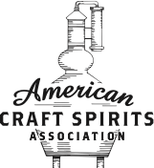
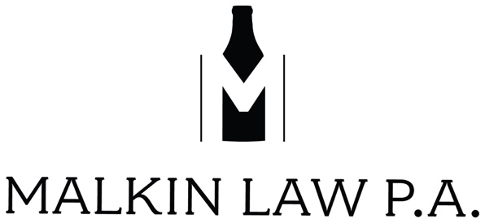

ARTICLES OF INCORPORATION

[INSERT ENTITY NAME].

[INSERT TYPE OF STATE ENTITY; E.G. NOT-FOR-PROFIT]

ARTICLE I

Name of Corporation and Duration

The name of this corporation is the [INSERT NAME OF ENTITY] (the "Corporation" or the “Guild”). This Corporation will continue in existence perpetually unless dissolved pursuant to law and consistent with the terms of the Bylaws of the Corporation.

ARTICLE II

Registered Agent

[INSERT NAME AND ADDRESS OF REGISTERED AGENT]

ARTICLE III

Statement of Purpose

The Corporation is a mutual benefit corporation organized and operated primarily to promote the common business and regulatory interests of and to improve the business conditions for those organizations, associations, and corporations that are in the [Insert State] craft distilling industry, including the [Insert State] (the “State”) agricultural industry that supports the State craft distilling. The primary activities of promotion, improving operational efficiency, improving safety and regulatory compliance, and improving the business environment for the State's craft distillers will be achieved as follows:

- [Insert Purpose of Guild: An Example - To promote [Insert State] craft distillers both in and outside the State the Guild will produce brochures, press releases, a web site and events that highlight the State's distilleries and benefits to the State agricultural industry. These activities put State distilleries in front of a broad range of people who are potential customers of these products. These activities may be initiated by the Board of Directors and carried out by sub-committees, independent contractors or Guild volunteers.]

- [Example]The Board of Directors may initiate activities that help the members operate at a lower cost, operate more efficiently, or operate faster. These activities may include bulk purchase of materials such as glass or corks; putting together a resource guide of suppliers, and seeking out new suppliers.

- [Example] The Guild will work to improve member awareness of environmental, health and safety issues. This work may include reaching out to regulatory organizations for interpretations, procurement of safety or regulatory compliance contractors, and the production of reference guides or resources for safety or compliance related equipment. This work will not include safety certification.

- Under the auspice of improving the business environment for [Insert State] distilleries, the Guild will work with regulatory bodies such as the [Insert State Alcohol Beverage Control body and Insert State Name] legislature and the Federal Alcohol and Tobacco Tax and Trade Bureau. The Guild will work with these and other agencies in a two-way exchange of ideas and discussion of issues to further the business environment for [Insert State] distilleries. These activities will be at the direction or initiated by the Guild Board of Directors and carried out by Guild members or designees.

- [Insert Any Additional Purposes or Ways of Working]

Notwithstanding any provision of these Articles of Incorporation, neither the Board of Directors nor the Corporation has the power or authority to engage in any act that will prevent the Corporation from being an organization described in Section 501(c)(6) of the Internal Revenue Code of 1986, as amended. Subject to the foregoing, and subject to and in furtherance of the purposes for which it is organized, the Corporation possesses all of the rights, privileges, and powers conferred by the said Code or any other law.

ARTICLE IV

Members

The Corporation has have one (1) or more classes of members as specified in the Corporation’s Bylaws. The terms and conditions of membership of each class will be as specified in the Corporation’s Bylaws.

ARTICLE V

Distribution and Dissolution

No part of the net earnings of the Corporation inures to the benefit of or may be distributable to its members, directors, officers or other private persons. Upon dissolution of the Corporation, the Board of Directors, after paying or making provision for the payment of all liabilities of the Corporation, will dispose of all the assets of the Corporation in furtherance of the Corporation’s purposes by distribution to one (1) or more other tax-exempt, nonprofit organizations as the Board of Directors determine.

ARTICLE VI

Limitation on Liability

The private property of the members, directors, officers, employees and members of the Corporation will not, as such, be liable for the obligations of the Corporation. A director of the Corporation will not be liable to the Corporation or its members for monetary damages for breach of directors duties to the Corporation or its members, except for breaches of the directors duty of loyalty to the Corporation or its members; acts or omissions not in good faith or that involve intentional conduct of a knowing violation of the law; transactions from which a director derived an improper economic benefit; or conflict of interest transactions, loans or guarantees for directors and officers or unlawful distributions.

ARTICLE VII

Indemnification of Officers and Directors

The Corporation may indemnify any directors, officers, employees, incorporators, and shareholders of the corporation from any liability regarding the Corporation and the business of the Corporation, unless the person fraudulently and intentionally violated the law or maliciously conducted acts to damage or defraud the Corporation, or as otherwise provided under applicable State law.

ARTICLE VIII

Principal Place of Business

[Insert Address]

ARTICLE IX

Amendments

These Articles of Incorporation may be amended in the manner authorized by law and the Bylaws of the Corporation at the time of amendment.

ARTICLE X

[Insert State Requirements for Filing/Signing]

